**Project Design Phase II** _ **Data Flow Diagram & User Stories**

**Project Title**: Smart Solution for Railways **Team ID**: PNT2022TMID42986

**Data Flow Diagrams:**

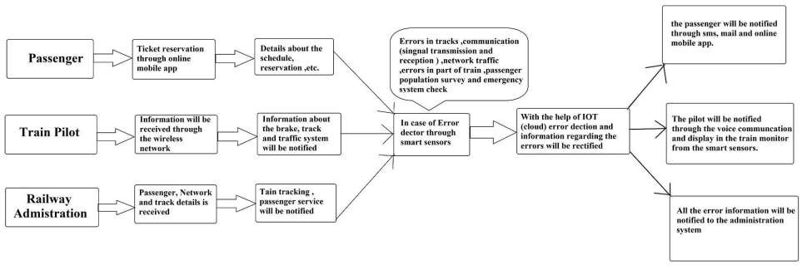

**User Stories**

|  |  |  |  |  |  |  |
| --- | --- | --- | --- | --- | --- | --- |
| **User Type** | **Functional**  **Requirement**  **(Epic)** | **User Story Number** | **User Story / Task** | **Acceptance criteria** | **Priority** | **Release** |
| Customer  (Mobile user) | Registration | USN-1 | As a user, I can register for the tickets by entering my email, and password, and confirming my password. | I can access my account/dashboard | High | Sprint-1 |
|  |  | USN-2 | As a user, I will receive a confirmation email once I have registered for the tickets. | I can receive a confirmation email & click confirm | High | Sprint-1 |
|  |  | USN-3 | As a user, I can register for the application through the Railway application. | I can register & access the dashboard with a registration login. | Low | Sprint-1 |
|  |  | USN-4 | As a user, I can register for the application through Online websites |  | Medium | Sprint-2 |
|  | Login | USN-5 | As a user, I can log into the application by entering my email & password |  | High | Sprint-1 |
| Train pilot | Dashboard | USN-6 | To get information regarding the train system, users check the system’s status through mobile applications or the dashboard display. | I can access it through the mobile app. |  | Sprint -1 |
|  |  | USN-7 | While traveling the status of the track will display in the dashboard. |  | Medium | Sprint -2 |
|  |  | USN-8 | other information from the admin will be displayed with an alert in the dashboard display |  | High | Sprint -2 |
| Administrator |  | USN-9 | The Railway network can be monitored from the base station of the railway | Access through the wireless network and computer system | High | Sprint -1 |
|  |  | USN-10 | In the computer system, the railway network traffic can be analysed and easy paths can be chosen. |  | High | Sprint -1 |
|  |  | USN-11 | In case of a communication signal error or problem, it will be displayed on the monitor so that the data can be sent again. |  | High | Sprint -1 |
|  |  | USN-12 | The error in the tracks will be informed to the train pilot’s admin and received through the mobile app or computer system. | Can be accessed through the display system ie computer system in the train | High | Sprint -1 |
|  |  | USN-13 | The passenger details will be automatically saved on the database of the admin computer system. |  | Medium | Sprint -1 |
| Customer Care  Executive |  | USN-14 | A portal is been arranged for the passenger help. the passenger can directly make a call to the respective number and ask for help | Can be accessed through telephony itself | High | Sprint -1 |
|  |  | USN-15 | Passengers can text the respective number through the mobile app. |  | Medium | Sprint -2 |
| Customer  (Web User) | Passenger objection and feedback | USN-16 | Passenger call to give their feedback to the railway website. |  | High | Sprint -2 |
|  |  | USN-17 | In case of any software error from the railway side, it can be reported to the inquiry desk through mail or message. | Accessed through mail or SMS | High | Sprint -2 |